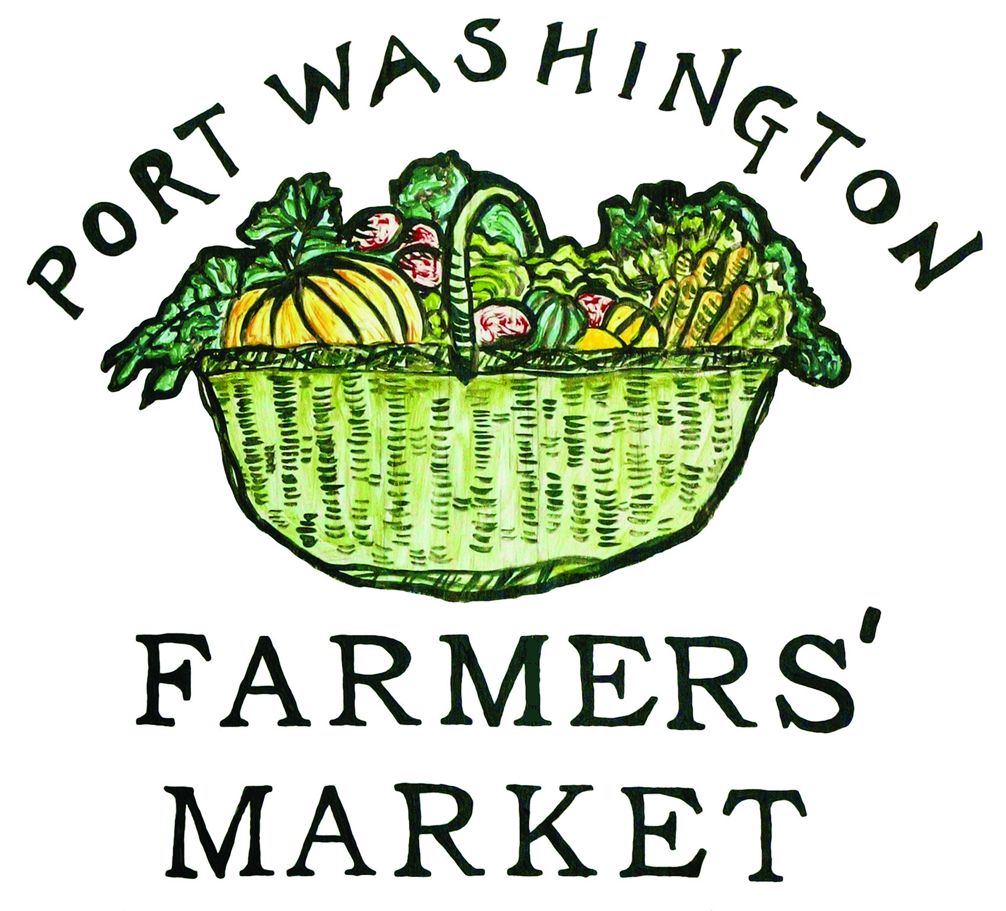
PORT WASHINGTON
FARMERS’ MARKET
2025 Vendor Application

Port Washington Town Dock
June 7, 2025 - October 25, 2025
8am - 12pm
www.pwfarmersmarket.org

- New Vendor
- Vendor Renewal

Vendor Name: _________________________________________________
Contact Name: _________________________________________________
Phone Number: _________________________________________________
Email Address: ________________________________________________
Mailing Address: _______________________________________________
_______________________________________________
Website: ______________________________________________________
Social Media: __________________________________________________

_____________________________________
Authorized approval
___________________________________Date
_____________________________________
Signature
Please list the products you will be selling at the market. Priority will be given to organic food products:

___________________________________________________________________________________

___________________________________________________________________________________

___________________________________________________________________________________

___________________________________________________________________________________
Please attach required documentation:
___ Certificate of Liability Insurance (required of all vendors)
___ Home Processor License (required if selling any food products made in home kitchens)
Available at https://agriculture.ny.gov/food-safety/home-processing

___ Other

